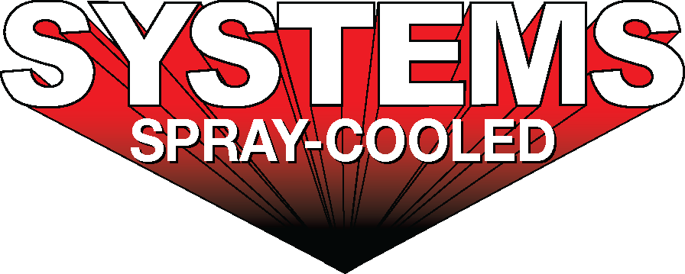
For sales/reader service inquiries:  Contact: The Systems Group  214 N Washington Ave, Ste. 700  El Dorado, AR 71730  (870) 862-1315  E-mail info@tsg.bz | For media inquiries:  Contact: Kyle Morgan  The Systems Group  (870) 882-1500  E-mail: kmorgan@tsg.bz

Systems installs and commissions new Spray-Cooled™ Electric Arc Furnace (EAF) equipment and a complete engineering package
at EVRAZ Steel

For Immediate Release, February 2022 Nashville, TN –

The SYSTEMS Group, received an order from EVRAZ North America, for the installation of Spray-Cooled™ equipment at its steelmaking facility located in Pueblo, Colorado. The 2022 turn key project includes new spray-cooled Electric Arc Furnace (EAF) equipment and a complete engineering package that covers a laser scan of the entire melt shop, design and layout all of the piping, and engineering of the required infrastructure changes.
The Spray-Cooled™ equipment will cover 100 percent of EVRAZ Pueblo's furnace cooling needs, to include the roof, elbow, and sidewall. The EAF sidewall will include a sloped hot face to help protect the refractory brick, burner blocks, and slag door area and will supply water directly to the oxy-fuel burners, slag door, and EBT auto-sander, minimizing water hoses and connections. The roof will be a new steep cone design for cooling optimization and extended lifetime.

EVRAZ Pueblo, established in 1881 as Colorado Fuel and Iron (CFI), helped build the American west. EVRAZ produces steel rail, seamless pipe, rod and coiled reinforcing bar. The furnace upgrade falls in line with EVRAZ’s 2023 rail mill expansion project.
The decision to install Spray-Cooled™ equipment at EVRAZ was based on the need for the safest, most environmentally friendly, lowest cost option (supply and maintenance) along with the extended life and performance for water-cooled equipment.
For product information, go to https://spraycooled.tsg.bz/. For general information, contact The Systems Group at 870-862-1315 (U.S./Canada); email info@tsg.bz web www.tsg.bz.

# # #

