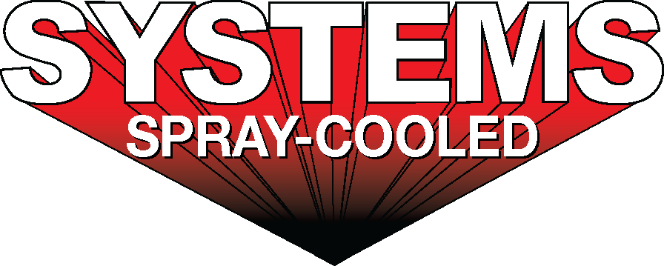
For sales/reader service inquiries:  Contact: The Systems Group  214 N Washington Ave, Ste. 700  El Dorado, AR 71730  (870) 862-1315  E-mail info@tsg.bz | For media inquiries:  Contact: Kyle Morgan  The Systems Group  (870) 882-1500  E-mail: kmorgan@tsg.bz

Systems Spray-Cooled provides its 1,000th Spray-Cooled ™ component with recent order to Nucor Steel Berkeley

For Immediate Release, Nashville, TN --

Earlier this year, Systems Spray-Cooled delivered two (2) electric arc furnace (EAF) roofs and (2) elbows to Nucor Steel Berkeley. The new steep sloped roofs and modernized elbows replace the original Spray-Cooled ™ equipment supplied back in 1996 for Berkeley’s start-up, achieving 23 years of service life!

These components were Systems’ 999th, 1000th, 1001st and 1002nd piece of Spray-Cooled ™ equipment supplied in the company’s 33 years of designing and manufacturing Spray-Cooled ™ furnace parts. Nucor continued its push for the safest, lowest cost option for water-cooled melt shop equipment.

For product information, go to https://spraycooled.tsg.bz/. For general information, contact The Systems Group at 870-862-1315 (U.S./Canada); email info@tsg.bz web www.tsg.bz.

# # #

