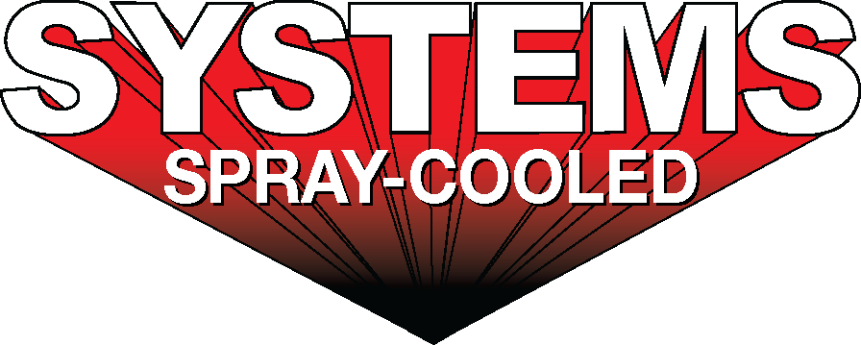
For sales/reader service inquiries:  Contact: The Systems Group  214 N Washington Ave, Ste. 700  El Dorado, AR 71730  (870) 862-1315  E-mail info@tsg.bz | For media inquiries:  Contact: Kyle Morgan  The Systems Group  (870) 882-1500  E-mail: kmorgan@tsg.bz

Systems Spray-Cooled Recently Completes BRS Phase II Melt Shop Expansion

For Immediate Release, May 2021 Nashville, TN --
As part of its Phase Two expansion that was recently completed, Big River Steel in Osceola, Arkansas installed and commissioned new Spray-Cooled™ on furnace electric arc furnace (EAF) equipment including a roof, elbow, sidewall and off-gas duct work with Systems Spray-Cooled from The Systems Group.
The EAF roof is a gantry style roof with a steep cone hot face profile for optimization and extended lifetime. The elbow incorporates a new integrated drain design that eliminates bolted connections for quicker change outs. The EAF sidewall incorporates a unique proprietary hot face profile that includes integrated ‘bump-outs’ to help protect the burners and refractory bricks, and reduce scrap jams at the slag door opening area.
As part of the project, Systems Spray-Cooled partnered with SMS Group to provide a complete Spray-Cooled™ Direct Evacuation Control System (DECS) consisting of a D1 downcomer duct, Drop-out Chamber (DOC) and downstream duct for all the water-cooled equipment. The D1 downcomer duct is hydraulically actuated on a fixed rail support system that allows for real-time air gap adjustment. The DOC is a panelized, self-supported design consisting of 20 sidewall and roof panel segments, a hydraulically actuated access door for cleanout, and a manually actuated emergency exit access man door. The downstream duct includes an electric driven actuator, and 12 sections of duct work (D2 through D13) totaling 236 feet in length and including a support structure tower with access platforms and ladders for the vertical duct section. Big River Steel expects the spray-cooled duct work will cool the off-gas more efficiently than typical tubular duct work. In all, 33 pieces of spray-cooled equipment were installed and commissioned at Big River Steel for the Phase Two expansion.
Big River Steel’s decision to install Spray-Cooled™ equipment was based on the need for the safest, most reliable solution when considering long term maintenance costs.
For product information, go to https://spraycooled.tsg.bz/. For general information, contact The Systems Group at 870-862-1315 (U.S./Canada); email info@tsg.bz web www.tsg.bz.

# # #

