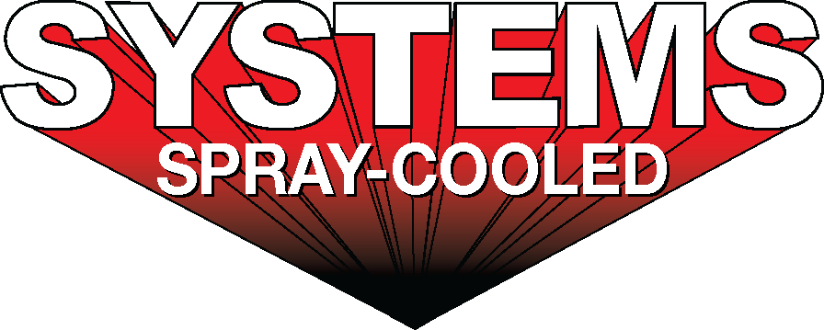
For sales/reader service inquiries:  Contact: The Systems Group  214 N Washington Ave, Ste. 700  El Dorado, AR 71730  (870) 862-1315  E-mail info@tsg.bz | For media inquiries:  Contact: Kyle Morgan  The Systems Group  (870) 882-1500  E-mail: kmorgan@tsg.bz

Systems Spray-Cooled receives order from Big River Steel

For Immediate Release, Nashville, TN -- Systems Spray-Cooled received additional orders from Big River Steel and the SMS Group for the installation and maintenance of Spray-Cooled ™ equipment at Big River Steel’s steelmaking facility located in Osceola, Arkansas. As part of its recently announced Phase 2 expansion, Big River Steel is installing a second electric arc furnace.

The Spray-Cooled ™ equipment will cover 100% of Big River Steel’s furnace cooling needs and will include the furnace sidewall, roof, elbow and off-gas duct work. Big River Steel’s decision to again purchase and install Spray-Cooled ™ equipment was based on the success of the Spray-Cooled ™ equipment already installed and maintained by Systems Spray-Cooled

For product information, go to https://spraycooled.tsg.bz/. For general information, contact The Systems Group at 870-862-1315 (U.S./Canada); email info@tsg.bz web www.tsg.bz.

# # #

