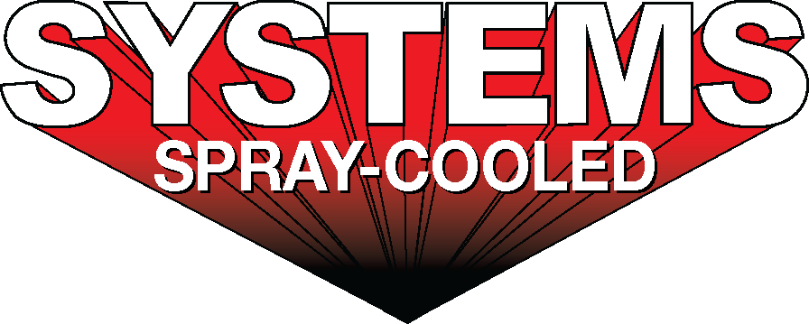
For sales/reader service inquiries:  Contact: The Systems Group  214 N Washington Ave, Ste. 700  El Dorado, AR 71730  (870) 862-1315  E-mail info@tsg.bz | For media inquiries:  Contact: Kyle Morgan  The Systems Group  (870) 882-1500  E-mail: kmorgan@tsg.bz

Systems Spray-Cooled Delivers Equipment to Nucor Steel Gallatin

For Immediate Release, September 2020 Nashville, TN --

Nucor Steel is expanding the steelmaking capacity at its flat-rolled sheet steel mill located in Ghent, KY. As part of the expansion project, Nucor is adding a new 175-ton EAF that will increase the mill’s annual capacity from 1.6 million tons to approximately 3 million tons of coiled steel.

Systems Spray-Cooled, of The Systems Group, was selected to supply the new EAF and has delivered its first shipment of Spray-Cooled™ equipment to Nucor Steel Gallatin. The Spray-Cooled™ equipment will include 100% of Nucor’s on furnace cooling needs, to include the EAF shells, roofs, and fume elbows. The EAF sidewall will incorporate a unique proprietary profile that includes integrated ‘bump-outs’ to help protect the burners and refractory bricks and reduce scrap jams at the slag door opening area. The roof will be a new steep cone design for optimization and extended lifetime. The elbow will incorporate a new integrated drain design that eliminates bolted connections for quicker change outs. Both the sidewall and roof will have an integrated Resistive Temperature Detector (RTD) system to enable zone monitoring of water temperatures throughout the furnace.

Nucor’s decision to install Spray-Cooled™ equipment was based on the success they have seen at their other EAF shops and on the need for the safest, most environmentally friendly, lowest cost option (supply and maintenance) along with the extended life and performance for water-cooled equipment.

For product information, go to https://spraycooled.tsg.bz/. For general information, contact The Systems Group at 870-862-1315 (U.S./Canada); email info@tsg.bz web www.tsg.bz.

# # #

