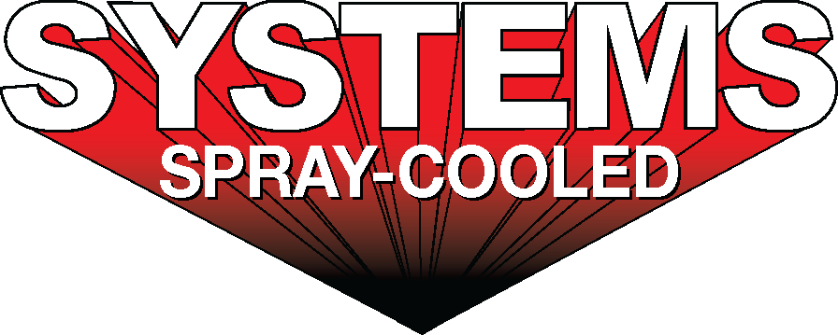
For sales/reader service inquiries:  Contact: The Systems Group  214 N Washington Ave, Ste. 700  El Dorado, AR 71730  (870) 862-1315  E-mail info@tsg.bz | For media inquiries:  Contact: Kyle Morgan  The Systems Group  (870) 882-1500  E-mail: kmorgan@tsg.bz

Systems Spray-Cooled installs and commissions a new Spray-Cooled™ EAF Roof and Elbow at Industeel Belgium

For Immediate Release, June 2021 Nashville, TN –

ArcelorMittal Industeel Belgium (“Industeel”) has installed and successfully commissioned a new Spray-Cooled™ Electric Arc Furnace (EAF) Roof and Elbow with Systems Spray-Cooled of The System Group. The execution of the project included: laser scanning the melt shop, basic and detailed engineering, design and supply of a new EAF Roof and Elbow, design and supply of new 2-point pick gantry arms, and the accompanying equipment that replaced the existing tubular equipment.
The full scope, in conjunction with partner tripleS GbR, also included roof alloy chute modifications and RTD monitoring. The conversion from a standard 4-point gantry pick roof to a 2-point cantilever roof and the addition of a complete handrail around the outside of the roof has significantly opened up the access to the roof and delta area allowing Industeel the ability to easily and safely change electrodes, deltas and the elbow. Industeel, Systems, and tripleS met the challenge of the COVID-19 pandemic and safely started up the EAF with all of the safety protocols being strictly followed.

The project was initially awarded in September 2019. Due to the COVID-19 pandemic, the equipment was delivered in August 2020 and start-up / commissioning was delayed until October 2020. The new spray-cooled roof and elbow upgrade brings significant safety and maintenance improvements to Industeel.
Industeel’s decision to install Spray-Cooled™ equipment was based on the need for the safest, most environmentally friendly, lowest cost option (supply and maintenance) along with the extended life and performance for water-cooled equipment.
For product information, go to https://spraycooled.tsg.bz/. For general information, contact The Systems Group at 870-862-1315 (U.S./Canada); email info@tsg.bz web www.tsg.bz.

# # #

