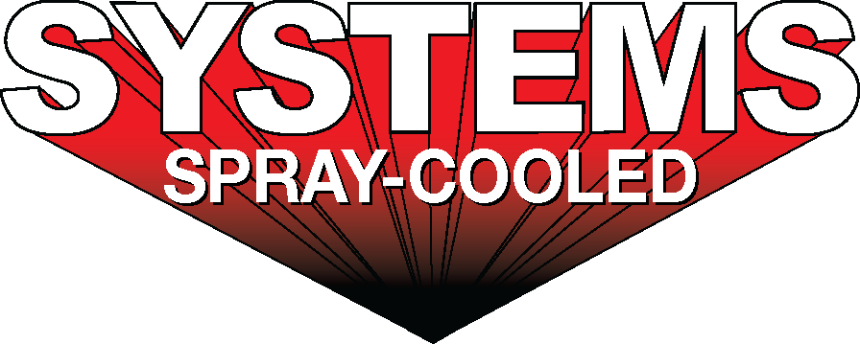
For sales/reader service inquiries:  Contact: The Systems Group  214 N Washington Ave, Ste. 700  El Dorado, AR 71730  (870) 862-1315  E-mail info@tsg.bz | For media inquiries:  Contact: Kyle Morgan  The Systems Group  (870) 882-1500  E-mail: kmorgan@tsg.bz
Systems Spray-Cooled receives contract from Nucor Steel Brandenburg
For Immediate Release, December 2020 Nashville, TN --

Systems Spray-Cooled, of The Systems Group, was selected to supply the electric arc furnace (EAF) Spray-Cooled™ equipment to Nucor Corporation’s new plate mill in Brandenburg, KY. The new EAF greenfield project includes equipment for a single EAF operation. The Spray-Cooled™ equipment will include 100% of Nucor’s on furnace cooling needs, to include the EAF shells, roofs, and fume elbows. The EAF roof will be a single-point cantilever roof lift design with flanged bolted gantry connection and a steep cone hot face profile for optimization and extended lifetime. The elbow will incorporate a new integrated drain design that eliminates bolted connections for quicker change outs. The EAF sidewall will incorporate a unique proprietary hot face profile that includes integrated ‘bump-outs’ to help protect the burners and refractory bricks and reduce scrap jams at the slag door opening area.
“We are pleased to continue our successful partnership with The Systems Group on one of our company’s largest capital investment projects,” said Johnny Jacobs, Vice President & General Manager of Nucor Steel Brandenburg. “When operational, this state-of-the-art mill will have the most diverse product offering of any plate mill in North America.”

For product information, go to https://spraycooled.tsg.bz/. For general information, contact The Systems Group at 870-862-1315 (U.S./Canada); email info@tsg.bz web www.tsg.bz.

