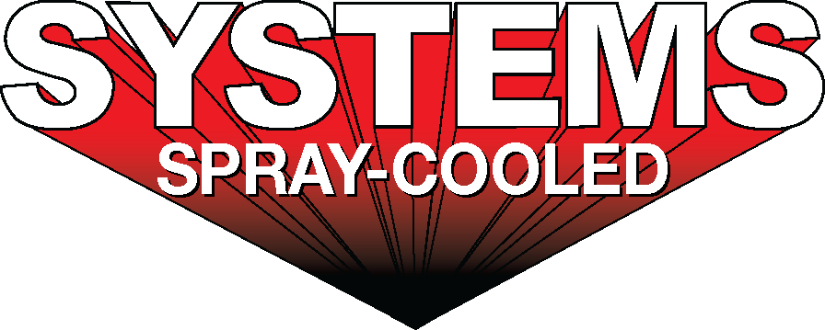

|  |  |
| --- | --- |
| ***For sales/reader service inquiries:***    Contact: The Systems Group  214 N Washington Ave, Ste. 700  El Dorado, AR 71730  (870) 862-1315  E-mail [info@tsg.bz](mailto:info@tsg.bz) | ***For media inquiries:***  Contact: Kyle Morgan  The Systems Group  (870) 882-1500  E-mail: [kmorgan@tsg.bz](mailto:kmorgan@tsg.bz) |

**Systems installs and commissions new Spray-Cooled™ Gravity Drained EAF Roof at Optimus Steel**

***For Immediate Release***, December 2021 Nashville, TN *–*

As part of its mill modernization upgrade that was completed last month, Optimus Steel, Beaumont, TX installed and commissioned a new Spray-Cooled™ electric arc furnace (EAF) roof and elbow with Systems Spray-Cooled. The design-build-install project includes a new EAF roof, elbow, engineering, laser scans, and accompanying equipment that will replace its existing tubular equipment.  The full scope, in conjunction with Systems Contracting, includes piping and gantry modifications.

This project marks the first ever gravity drained Spray-Cooled™ EAF roof.  The EAF roof and piping were designed such that venturi suction pumps are not required to evacuate water from the roof during slag and tap.  This eliminates the need for the pumps as well as the required piping.  Also, the EAF roof was converted from a traditional 4-point gantry lift roof to a 2-point gantry lift roof.  Optimus will eliminate the associated downtime and maintenance issues with their old gantry arm design.  The new design will address current operational issues and will allow for better roof alignment and delta changes.  The elbow incorporates a new integrated drain design that eliminates bolted connections for quicker change outs.  The roof diameter has been oversized to allow for a larger furnace sidewall in the future.   This project is expected to be the first phase of a multi-phase melt shop upgrade to a more optimized design with the upper shell and off-gas system to follow.

Optimus Steel, located in Beaumont, Texas, produces a wide range of high-quality wire rods, coiled rebar, and billets.  Optimus Steel is logistically situated near Houston to provide value added solutions that help their customers in the construction, automotive, energy, consumer, and manufacturing markets.

Optimus Steel’s decision to install Spray-Cooled™ equipment was based on the need for the safest, most environmentally friendly, most reliable solution when considering maintenance costs.

For product information, go to https://spraycooled.tsg.bz/. For general information, contact The Systems Group at 870-862-1315 (U.S./Canada); email [info@tsg.bz](mailto:info@tsg.bz) web [www.tsg.bz](http://www.tsg.bz).

# # #