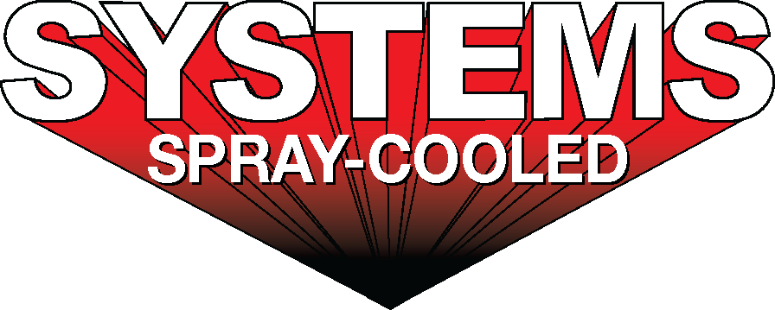
For sales/reader service inquiries:  Contact: The Systems Group  214 N Washington Ave, Ste. 700  El Dorado, AR 71730  (870) 862-1315  E-mail info@tsg.bz | For media inquiries:  Contact: Kyle Morgan  The Systems Group  (870) 882-1500  E-mail: kmorgan@tsg.bz

Systems Spray-Cooled receives an order to upgrade Optimus Steel EAF

For Immediate Release, July 2020 Nashville, TN --

Optimus Steel has placed an order for a furnace upgrade solution with Systems Spray-Cooled of The Systems Group. The 4th quarter 2020 turn-key project includes a new Spray-Cooled™ Electric Arc Furnace (EAF) Roof, a new Spray-Cooled™ Elbow, the accompanying equipment that will replace its existing tubular equipment, and a complete engineering package that covers a laser scan of the entire melt shop, design and layout all of the piping, and engineering of the required infrastructure changes.

The engineering portion includes modifying their current 4-point gantry lift roof to a 2-point gantry lift design. By removing the (2) existing long gantry arms and replacing them with customized short arms, Optimus Steel will eliminate the associated downtime and maintenance issues with their old gantry arms design. The new design will address current operational issues and will allow for better roof alignment and delta changes. The elbow spray water will be supplied and drained from the roof minimizing hoses and connections. The roof diameter will be oversized to allow for a larger furnace sidewall in the future. This project is expected to be the first phase of a multi-phase melt shop upgrade to a more optimized design with the upper shell and off-gas system to follow.

Optimus Steel, located in Beaumont, Texas, produces a wide range of high-quality wire rods, coiled rebar, and billets. This mill has been recognized with awards for safety, community service, outstanding engineering, and environmental improvement throughout the years. Optimus Steel is logistically situated near Houston to provide value added solutions that help their customers in the construction, automotive, energy, consumer, and manufacturing markets.

Optimus Steel's decision to install Spray-Cooled™ equipment was based on the need for the safest, most environmentally friendly, lowest cost option (supply and maintenance) along with the extended life and performance for water-cooled equipment.

For product information, go to https://spraycooled.tsg.bz/. For general information, contact The Systems Group at 870-862-1315 (U.S./Canada); email info@tsg.bz web www.tsg.bz.

# # #

