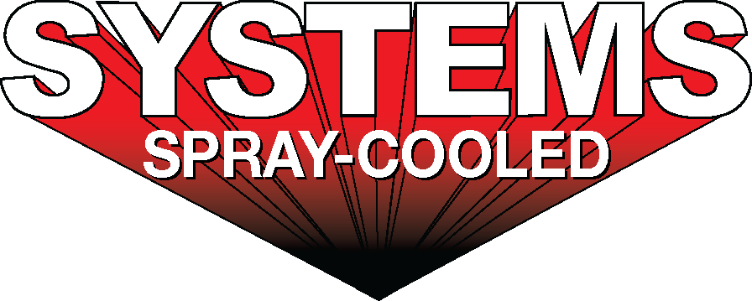
For sales/reader service inquiries:  Contact: The Systems Group  214 N Washington Ave, Ste. 700  El Dorado, AR 71730  (870) 862-1315  E-mail info@tsg.bz | For media inquiries:  Contact: Kyle Morgan  The Systems Group  (870) 882-1500  E-mail: kmorgan@tsg.bz

Systems Spray-Cooled receives order from Steel Dynamics, Inc.

For Immediate Release, June 2020 Nashville, TN --

Systems Spray-Cooled has received an order from Steel Dynamics, Inc. for Spray-Cooled™ equipment at their new mill in Sinton, TX currently under construction. The 2021 project includes equipment for their (2) Electric Arc Furnaces. The Spray-Cooled™ equipment will cover 100% of SDI’s furnace cooling needs and will include the EAF shell, roof and elbow. The EAF sidewall will incorporate new ‘bump-outs’ to help protect the burners and refractory bricks. The roof will be a new steep cone design for optimization and extended lifetime.

SDI’s decision to purchase Spray-Cooled equipment was based on the success they have seen at their other EAF shops and on the need for the safest, lowest cost option (supply and maintenance) along with the extended life and performance for water-cooled equipment.

For product information, go to https://spraycooled.tsg.bz/. For general information, contact The Systems Group at 870-862-1315 (U.S./Canada); email info@tsg.bz web www.tsg.bz.

# # #

