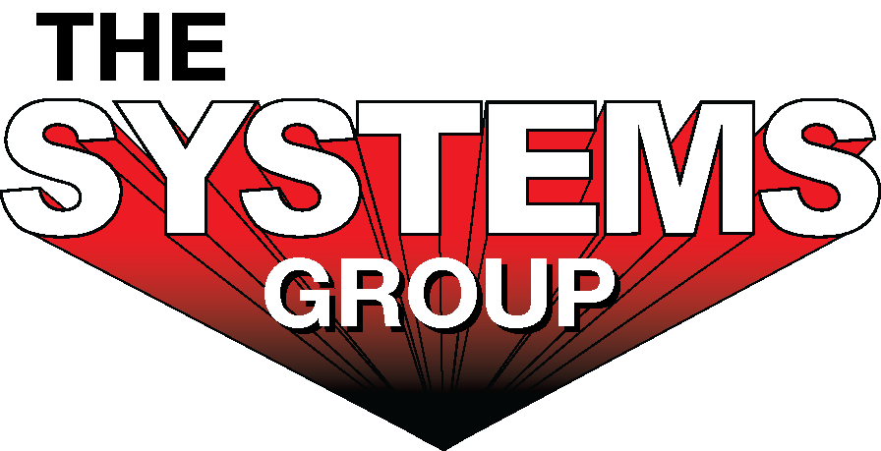

For sales/reader service inquiries:  Contact: The Systems Group  214 N Washington Ave, Ste. 700  El Dorado, AR 71730  (870) 862-1315  E-mail info@tsg.bz | For media inquiries:  Contact: Kyle Morgan  The Systems Group  (870) 882-1500  E-mail: kmorgan@tsg.bz

Systems announces large expansion to El Dorado fabrication and machine shop, adding 60 new jobs

For Immediate Release, May 2022 El Dorado, AR –

The Systems Group is pleased to announce a new expansion to their main fabrication and machine shop in El Dorado, AR. With the growth of Systems in all of their business units focused on the U.S. steel production industry, they will be purchasing 47 acres of land next to their current El Dorado facility and expanding operations to make more of their patented Spray-Cooled™ equipment (used to prevent Electric Arc Furnaces from melting while producing new, liquid steel).
Systems plans to invest in land, equipment, and buildings and hire 60 new employees in El Dorado. The expansion is already underway, and the company is currently looking for good welders, fitters, and fabricators to join their team.
“This is an exciting time in the steel industry,” said Lee Morgan, president and owner of Systems. “America is going through a resurgence of bringing manufacturing jobs back to the USA, and our business is benefiting from that. The steel industry is investing in new mills and expansions, and as a result, Systems’ orders are dramatically increasing for our Spray-Cooled™ equipment, SMAC air cleaners, and our maintenance and construction services. This expansion will help us triple the equipment we currently build in Arkansas.”
Charles Hays Jr., CEO of Systems explained why the company chose El Dorado. “We are very excited to bring more jobs to South Arkansas. Most of our competitors build their equipment overseas and import it. We are proud to make our Spray-Cooled™ equipment right here in the USA. We proudly put ‘Made in the USA’ in big letters on our equipment and our customers love it. We are committed to growing in El Dorado.”
The Arkansas Economic Development Corporation (ADEC) has approved Systems’ expansion to participate in the Advantage Arkansas program to bring job growth to the state of Arkansas.
“The Systems Group continues to build on the momentum in the steel industry as more and more manufacturing jobs are returning to the country. We are excited that The Systems Group decided to expand their operations here in El Dorado and that they have found the people and business climate here that will enable them to meet the growing demands of their clients. Because of the confidence they have in our South Arkansas workforce, 60 employees will have jobs that will improve their financial bottom lines and quality of life.”
“The Systems Group is a great example of why we need to invest more in our skilled workforce. The new jobs being created in El Dorado are for welders, fitters, and fabricators – jobs that are in high demand throughout the state that can lead to lifelong career opportunities. We look forward to working with The Systems Group as they continue to grow.”
The Systems Group mission statement is “Engineered Solutions for a safer, more productive steel industry.” With this expansion they are delivering on this mission. Arkansas is now the leading steel making state in the USA, and Systems plans to be a vital part of that for a long time to come.

For more information, go to https://www.tsg.bz/. For general information, contact The Systems Group at 870-862-1315 (U.S./Canada); email info@tsg.bz web www.tsg.bz.

# # #

