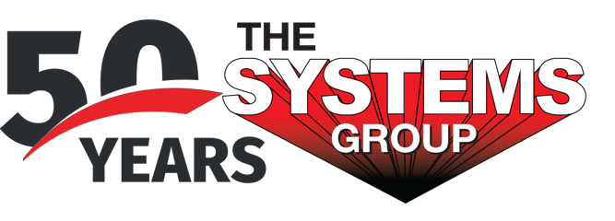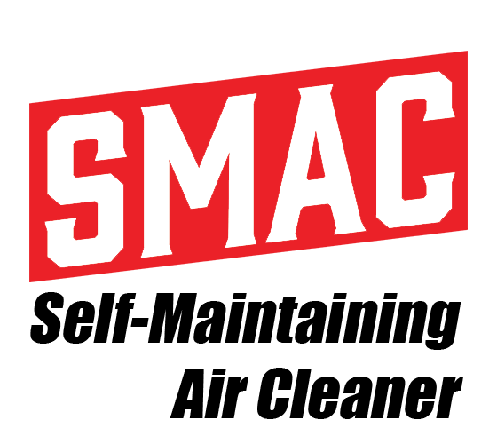
For sales/reader service inquiries:  Contact: The Systems Group  214 N Washington Ave, Ste. 700  El Dorado, AR 71730  (870) 819-9000  E-mail jlongmire@tsg.bz | For media inquiries:  Contact: Kyle Morgan  The Systems Group  (870) 882-1500  E-mail: kmorgan@tsg.bz

NEW SMAC MINI PULSE-CLEANED AIR CLEANER
OFFERS HOSPITAL GRADE FILTRATION FOR CRANE CABS

El Dorado, Ark., July 2021 – The Systems Group (TSG) has introduced a new pulse-cleaned industrial air cleaner that efficiently filters the inside of crane cabs for operator safety and comfort. Called the SMAC Mini, it is a compact version of the company’s Self-Maintaining Air Cleaner (SMAC), their flagship heavy-duty air filtration system for steel mills and heavy industry. The SMAC Mini is specifically designed for crane cabs, incorporating MERV 15 rated filtration via an easy-change nanofiber filter and provisions for direct mounting to a platform catwalk.

With a capacity of 700 CFM at 9” static pressure, the SMAC Mini continuously fills the crane cab with filtered clean air under positive pressure. This prevents all dust from the typically harsh environments found in steel mills from entering the enclosed operator space. Requiring only electrical power, the small-scale system is completely self-contained. It features integrated controls with a motor starter and pulsing system, an integrated air compressor for automatic filter cleaning, and a Minihelic® gauge that indicates when it is time for filter changeout. Constructed of heavy-duty 11 and 14 gauge steel, the powder-coated unit weighs only 386 pounds and is equipped with a 10” collar for easy duct connection during installation.

For product information, go to https://smac.tsg.bz/applications/room-pressurization/. For general information, contact The Systems Group at 870-862-1315 (U.S./Canada); email info@tsg.bz web www.tsg.bz.

# # #

