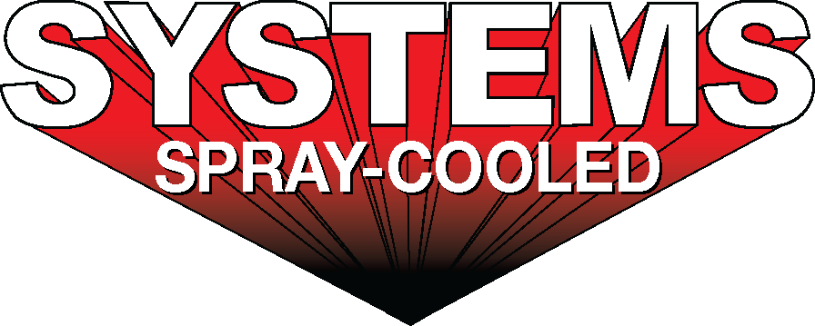
For sales/reader service inquiries:  Contact: Systems Spray-Cooled  877 Seven Oaks Blvd., Ste 500  Smyrna, TN 37167; U.S.  +1 (615) 366-7772  E-mail info@tsg.bz | For media inquiries:  Contact: Kyle Morgan  The Systems Group  +1 (870) 882-1500  E-mail: kmorgan@tsg.bz

Ovako Hofors Puts Safety at the Forefront with the First Spray-Cooled™ EAF Roof in the Nordic Region

July 24, 2017, El Dorado, Arkansas – Swedish steel producer Ovako has awarded Systems Spray-Cooled the contract to modernize and increase safety on their Electric Arc Furnace (EAF) with the first Spray-Cooled™ roof in the Nordic region, located at their bar, billet, tube, and rings facility in Hofors, Sweden.
After first being exposed to Spray-Cooled technology at the European Electric Steelmaking Conference in Italy, Ovako weighed the new technology against their current pressurized tubular roofs. The main concerns were implementing the technology with their environment (piping); otherwise, Ovako has been highly enthusiastic about the technology and saw clear advantages both for maintenance and for safety. Because Spray-Cooled™ equipment operates at atmospheric pressure, the cooling water is not pumped across the area to be cooled. Therefore, the potential for high pressure, high volume water leaks is eliminated.

Under the contract, the new roof will be engineered to work with their current furnace setup, as well as ‘future-proofed’ to integrate with planned furnace upgrades. To alleviate concerns about potential piping issues, the new roof will be engineered using state of the art 3D laser scans of the current furnace and surrounding mill. The 3D laser scan will aid in the design, especially since the available drawings are 25 years old and have discrepancies. It will also allow piping to be designed accurately for easy fitment and should greatly reduce or eliminate unforeseen issues in the process.

The Hofors steelmaking operation, based around ingot casting, has an annual capacity of about 500,000 tonnes of ingots. The tube rolling capacity is about 120,000 tonnes annually and the ring rolling capacity about 45,000 tonnes a year.

This is an unconventional cantilever-lift roof that will be fabricated in Germany. Ovako and Systems plan on commissioning the new roof in January of 2018.

For product information, go to https://spraycooled.tsg.bz/applications/eaf-roofs/. For general information, contact Systems Spray-Cooled at +1 (615) 366-7772; email info@tsg.bz web spraycooled.tsg.bz.

